**Coursework Brief - Detail Requirements**

1. Provide a brief history of both HTML and CSS standards including information on:

* Founder
* Revisions/versions and a key difference in each revisions/version
* Any companies involved in its evolution

2. List 5 HTML elements and 5 CSS styles that you are familiar with explaining briefly what they are typically used for.

Founder

This creation of the first website in the world and the building block of the creation of website, Hyper-text Markup Language (HTML) is attributed to a single man.

British physicist, Timothy (Tim) Berners-Lee while working at CERN (see any companies involved in its evolution) in 1989 proposed an internet-based hypertext system (figure 1). This structure would use HTML as a structure for the world wide web to be built on (While colloquially the usage of the term's internet, and world wide web (WWW) interchangeably this is not technically true. The internet refers to the network of connected computer networks. WWW is a connection of webpages found on the internet.) Its purpose to allow how webpages, and entire websites can be created web developers). Prior to this, Berners-Lee as a contractor for CERN proposed and then wrote the software project of Enquire in 1980. Enquire as a software was initially used internally within CERN as a method of exchanging files for approximately ten-thousand people in the CERN phonebook (Anon., n.d.).

Figure 1: Tim Berners-Lee proposal for the WWW (Anon., 2014)

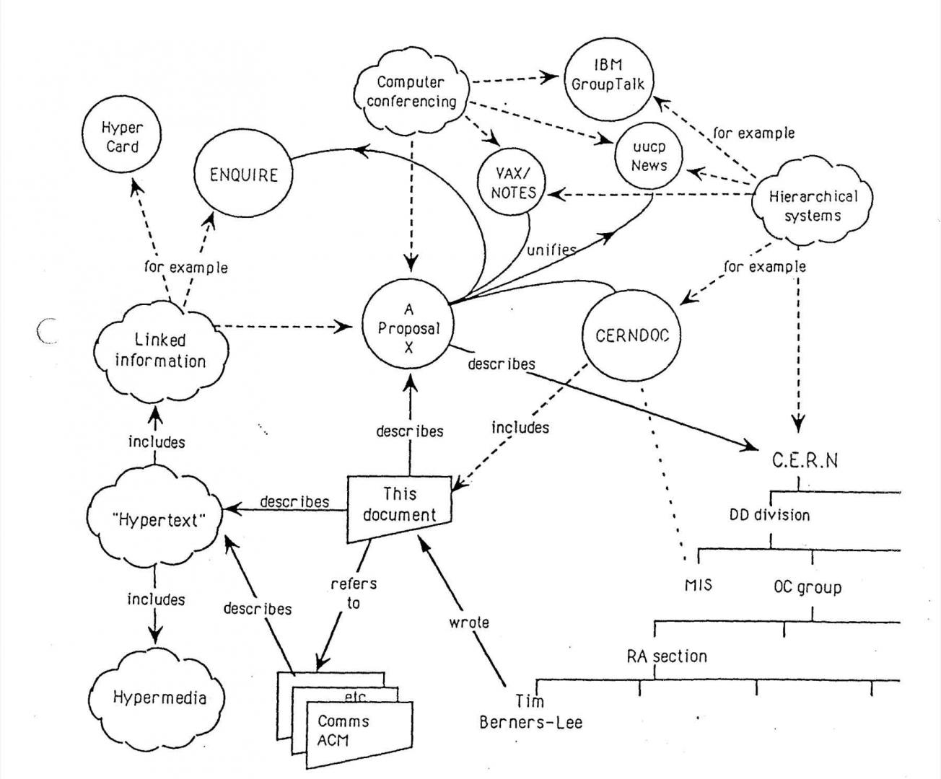

Over the next thirty-three-year Berners-Lee's first web page has supplied the basis for the foundation of the World Wide Web (figure 2), that has an estimated over 200 million active pages. Over 250,000 websites are created every day at an average of three websites per second (Anon., 2023). All these websites use HTML. This includes notable examples YouTube, Netflix, Wikipedia, and Pinterest. For these services to the global development of the Internet Tim Berners-Lee was knighted on 16th of July 2004 (Anon., 2004). In addition, to his knighthood Berners-Lee has received many honours throughout his lifetime. Time magazine was named in Time magazine’s greatest 100 minds of the twentieth century (Anon., 1999).

Figure 2: Closest existing screenshot of the original webpage (CERN, n.d.)

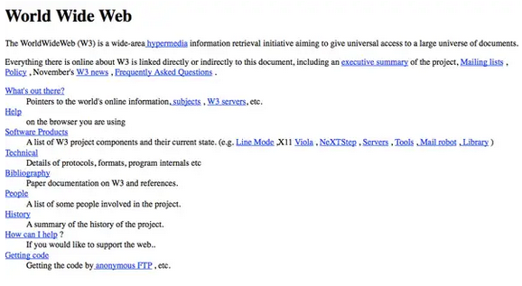

Cascading Stylesheets (CSS) was first proposed on the 10th of October 1994 by Norwegian web pioneer, and current activist Håkon Wium Lie with the first version of CSS invented two years later. During this time Lie worked with Tim Berners Lee creating the proposal of CSS for the presentation of webpages. The first of these versions CSS1 (see revisions/versions and a key difference in each revisions/version) was human readable and writable with Bert Bos as the Co-founder of CSS (Bos, n.d.). Awards and recognition were given to Lie, and Bos in the same way Berners-Lee was. Lie in 1999, was named to MIT Technology Review’s TR100, for inventors under the age of thirty-five (MIT, 1999).

Revisions/versions and a key difference in each revisions/version

The year 1993, was the first year that a version of HTML was released. HTML version 1.0. Two years before this, Berners-Lee began working on the idea that would eventually lead to the current version HTML 5 released in 2014. The points below show the timeline of HTML versions released, in addition to CSS with several significant differences detailed.

HTML

* 1989 – Tim Berners-Lee conceived the idea of HTML (see founder).
* 1991 – HTML 1.0 began development (see founder).
* 1993 – HTML 1.0 is developed and released commercially. Allows for image placement (Faulkner, 2016).
* 1995 - HTML 2.0 is released. Introduces tags for improved functionality (Faulkner, 2016).
* 1997 – HTML 3.0 add a series of new abilities called Netscape (see any companies involved in its evolution) extension tags. Text extensions in Netscape includes the font tag, and the base font tag. Font adjusts size of text placed between the tag and its corresponding end tag. Base font changes the default font size in Netscape, which by default is 3. These extensions lacked compatibility with other browsers (Williams, n.d.). Base font was removed from HTML 5.0 (Faulkner, 2016).
* 1999 - HTML 4.0 lasts for fifteen years as a major evolution of the standards of HTML. Supports CSS, for styling of webpage (Faulkner, 2016).
* 2014 – HTML fifth generation (5.0) supports multimedia and introduces new tags for large files sizes that can be accounted for (audio/video). Can embed videos into webpages for social media video sharing sites such as YouTube (Faulkner, 2016).

CSS

* 1994 – Idea proposed (see founder)
* 1996 - CSS1 published. Included many features that stay in CSS today. For example, text alignment, padding, border, and width (W3., 1996).
* 2016 – CSS2 released. Backwards compatible with CSS1 (Anon., 2023).
* 2017 - CSS3 published. Has supports media queries, and all modern web browsers (Mozilla, n.d.).

Any companies involved in its evolution

CERN, the European Organization for Nuclear Research, is one of the world's largest and most respected centres for scientific research (CERN, n.d.). CERN created HTML, and the WWW (see founder).

Netscape Communications was a computer services company best known for its Web browser, Navigator. Navigator was one of the two most popular Web [browser](https://www.techtarget.com/whatis/definition/browser)s in the 1990s (Anon., n.d.). Netscape supplies browser many key features still used in HTML 5.0 (see revisions, and a key difference in each revisions/version).

List 5 HTML elements and 5 CSS styles that you are familiar with explaining briefly what they are typically used for.

HTML uses “markup” to annotate text, images, and other content for display in a Web browser. Text is explained by the name of the element. For example, the tag <header> has every part of information at the top of a webpage. Once this section of the webpage has concluded it is closed off using a backslash (/header). In this example, the type of markup language of called descriptive markup. Sections of documents are labelled as to how to be handled within the webpage.

This is one of the three types of markup languages that HTML uses. The others are presentational markup, and procedural markup. Presentational markup uses traditional word processing systems hidden from editors, users, and human authors. Procedural markup combines instructions on text processing that are visibly manipulated by the author. An example of the latter case is Markdown and Troff (see terminology). Example of the formal markup include word processing systems (see terminology).

The examples below are all examples of HTML elements that use descriptive as their form of markup. These are all examples of markup language type descriptive. The element of strong, is used for formatting, h1 is used for formatting text, table for the defining of a table, area for defining an area of an image map, and meta for data the describes data.

* Strong
* H1
* Table
* Area
* Meta

The <strong> HTML element shows that its contents have strong importance, seriousness, or urgency. Browsers typically make the contents in bold type. Figure 3 shows an example of this with the text for a webpage. For this example, the text “this is dangerous” emphasis that a website is unsafe to use due to given of malware or viruses for the user's device. The strong tag in comparison to the p (paragraph) tag is given a bolder font style and spacing. The programming of this webpage is shown in figure four using the web development tool of Adobe Dreamweaver (see terminology & figure 4). Other html elements were used to make this possible including, the main element for the main contents of the webpage, article, for the independent placement of the image, and text of the webpage, and image (img) which allowed for the visibility of the red triangle with a white exclamation mark as a signifier of danger. All images are referenced below (see images references).

Figure 3: Image showing the HTML element of strong on a webpage

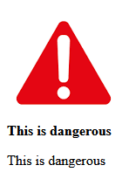

Figure 4: Image showing the HTML element of strong within Adobe Dreamweaver

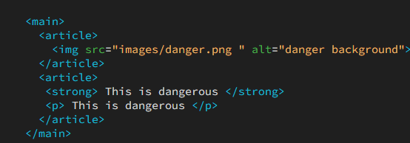

The <h1> to <h6> [HTML](https://developer.mozilla.org/en-US/docs/Web/HTML) elements are six levels of section headings. <h1> is the highest section level and <h6> is the lowest. Meaning that, within a given web page the text with the greatest font-size h1, followed by the next largest in terms of font-size, h2 and so on with the last being h6. H1 is often attributed to the title text on a web page. Figure 5 shows the differences in these font sizes. Each HTML element header is shown within Adobe Dreamweaver in figure 6.

Figure 5: Image showing the HTML element of strong within Adobe Dreamweaver



Figure 6: Image showing the HTML elements of H1-H6 within Adobe Dreamweaver

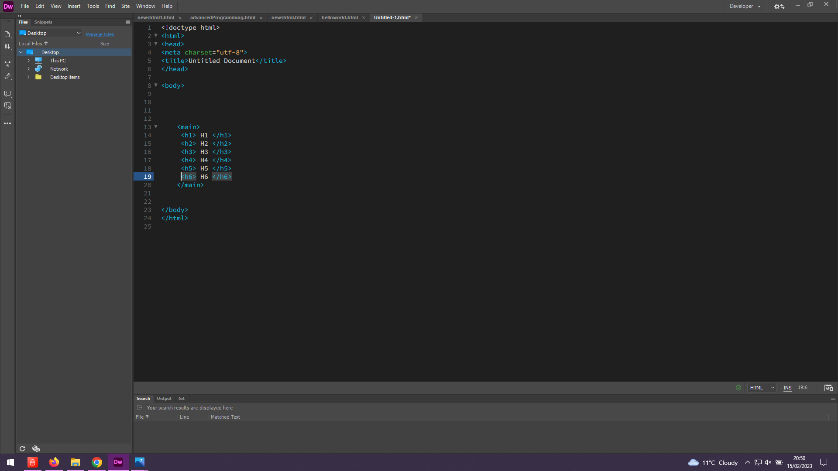

The <table> [HTML](https://developer.mozilla.org/en-US/docs/Web/HTML) element stands for tabular data — that is, information presented in a two-dimensional table formed of rows and columns of cells holding data (Anon., n.d.). For example, if one table holds names of students, their ages, and the courses they are studying, the name, ages, and course would be headings (<th>) contained within a single row column (<tr>). Each opening row tag and closing tag would have information for a single student in this scenario in the table until the table is closed (/table).

The <area> [HTML](https://developer.mozilla.org/en-US/docs/Web/HTML) element defines an area inside an image map that has predefined clickable areas. An *image map* allows geometric areas on an image to be associated with [hypertext links](https://developer.mozilla.org/en-US/docs/Glossary/Hyperlink). (Anon., n.d.). This area will have a shape nested inside a map tag. A specific piece of a webpage can be given functionality. If part of an image is clicked for instance, a new webpage can be brought up on the screen.

The <meta> [HTML](https://developer.mozilla.org/en-US/docs/Web/HTML) element is [metadata](https://developer.mozilla.org/en-US/docs/Glossary/Metadata) that cannot be represented by other HTML meta-related elements, like [<base>](https://developer.mozilla.org/en-US/docs/Web/HTML/Element/base), [<link>](https://developer.mozilla.org/en-US/docs/Web/HTML/Element/link), [<script>](https://developer.mozilla.org/en-US/docs/Web/HTML/Element/script), [<style>](https://developer.mozilla.org/en-US/docs/Web/HTML/Element/style) or [<title>](https://developer.mozilla.org/en-US/docs/Web/HTML/Element/title) (Anon., n.d.). Other relevant information such as author of the webpage, and a description of the webpage can be found in the header sector of the HTML page.

Typically, these elements each serve a specific purpose. The elements within CSS (Cascading Stylesheets) have a definitive intention, also. Figures 3, and 5 show how a webpage can look without CSS. CSS is used to style existing HTML elements. The examples below are existing elements of CSS.

* Color
* Position
* Opacity
* Font-family
* Border

Color can both change the color of the background of the webpage, and the text displayed on the screen. Combined with the header's tags (see above), this can supply a specific color to a heading that does not exist anywhere else on the webpage.

Positioning of information on a webpage, can be positioned in the following ways:

* Static
* Relative
* Fixed
* Absolute
* Sticky

Opacity is how transparent an image is on a webpage. The element is used to supply a translucent (see-through) effect for an image.

Font-Families have different font styles. Some of italic, while others are bold, regular, and italic.

Border is the area around a tag in HTML, and CSS. It can have a width, style, and color (among other properties).

These elements are all used for the presentation of a webpage, in a visually appealing manner.

Terminology:

Web developers

Adobe Dreamweaver

Markdown

Troff

Word-processing systems

Image References:

Figure 3’s danger symbol (Anon., n.d.).

Bibliography:

W3. (No date) *A Brief History of the Web* [online] Available at: https://www.w3.org/DesignIssues/TimBook-old/History.html / (Accessed: February 15, 2023).

# Cern. (2014) *World Wide Web born at CERN 25 years ago* [online] Available at: https://home.cern/fr/node/3939 / (Accessed: February 15, 2023).

# Time. (1999) *Time 100 Persons of The Century* [online] Available at: https://content.time.com/time/magazine/article/0,9171,26473,00.html / (Accessed: February 18, 2023).

Anon. (2023) *Total number of Websites* [online] Available at: https://www.internetlivestats.com/total-number-of-websites/ (Accessed: February 18, 2023).

BBCNews. (2003) *Web’s inventor gets a knighthood* [online] Available at: http://news.bbc.co.uk/2/hi/technology/3357073.stem/ (Accessed: February 18, 2023).

Frauenfelder, M. (2004) *Sir Tim Berners-Lee* [online] Available at: https://www.technologyreview.com/2004/10/01/232234/sir-Tim-Berners-Lee/ (Accessed: February 18, 2023).

Bos, B. (1999) *Home Page of Bert Bos* [online] Available at: https://www.w3.org/People/Bos/ (Accessed: February 18, 2023).

MIT. (No Date) *Hakon Wium Lie* [online] Available at: https://www.technologyreview.com/2004/10/01/232234/ hakon-wium-lie/ (Accessed: February 18, 2023).

CERN. (No Date) *The birth of the Web* [online] Available at: https://www.home.cern/science/computing/birth-web/ (Accessed: February 18, 2023).

Williams, B. (No Date) *Fooling Around with the Netscape Extensions* [online] Available at: https://www.billwilliams.org/HTMLhelp/bullet-types.html/ (Accessed: February 18, 2023).

Faulkner, S. (2016) *The Element of HTML* [online] Available at: https://w3c.github.io/elements-of-html/ (Accessed: February 18, 2023).

Cern (No Date) *Cern*[online] Available at: https://www.home.cern// (Accessed: February 18, 2023).

TechTarget (No Date) *Netscape* [online] Available at: https://www.techtarget.com/whatis/definition/Netscape / (Accessed: February 18, 2023).

W3 (1996) *Cascading Style Sheets, Level 1* [online] Available at: https://www.w3.org/TR/REC-CSS1/ (Accessed: February 18, 2023).

W3 (2023) *CSS Snapshot 2023* [online] Available at: https://www.w3.org/TR/CSS/#css/ (Accessed: February 18, 2023).

Mozilla (No Date) *CSS* [online] Available at: https://developer.mozilla.org/en-US/docs/Web/CSS/ (Accessed: February 18, 2023).

# Mozilla. (No date) *<strong>: The Strong Importance element*. [online] Available at: https://developer.mozilla.org/en-US/docs/Web/HTML/Element/strong / (Accessed: February 15, 2023).

Mozilla. (No date) *<h1>–<h6>: The HTML Section Heading elements*. [online] Available at: https://developer.mozilla.org/en-US/docs/Web/HTML/Element/Heading_Elements / (Accessed: February 15, 2023).

Mozilla. (No date) *<table>: The Table Element.* [online]Available at: https://developer.mozilla.org/en-US/docs/Web/HTML/Element/table/ (Accessed: February 15, 2023).

Mozilla. (No date) *<area>: The Image Map Area Element*. [online] Available at: https://developer.mozilla.org/en-US/docs/Web/HTML/Element/area/ (Accessed: February 15, 2023).

Mozilla. (No date) *<meta>: The metadata Element*. [online] Available at: https://developer.mozilla.org/en-US/docs/Web/HTML/Element/meta/ (Accessed: February 15, 2023).

Anon. (No date) *Warning Symbol* [online] Available at: https://stock.adobe.com/ie/search?k=warning+symbol / (Accessed: February 15, 2023).